**UI Policy**

**3.1 Create Catalog Ui policies**

|  |  |
| --- | --- |
| Date | **25 June 2025** |
| Team ID | **LTVIP2025TMID29028** |
| Project Name | **Laptop Request Catalog Item** |
| Maximum Marks | **5 Marks** |

1. Click on all>> search for service catalog
2. Select maintain item under catalog definition
3. Search for ‘laptop request’ which is created before
4. Select ‘laptop request’ and scroll down click on “Catalog Ui policies”
5. In the catalog ui policies related list tab click on new
6. Give short description as: show accessories details
7. Set the Catalog Condition in the related list tab ‘when to apply’

                  [field: additional_ accessories, operator: is, value: true]

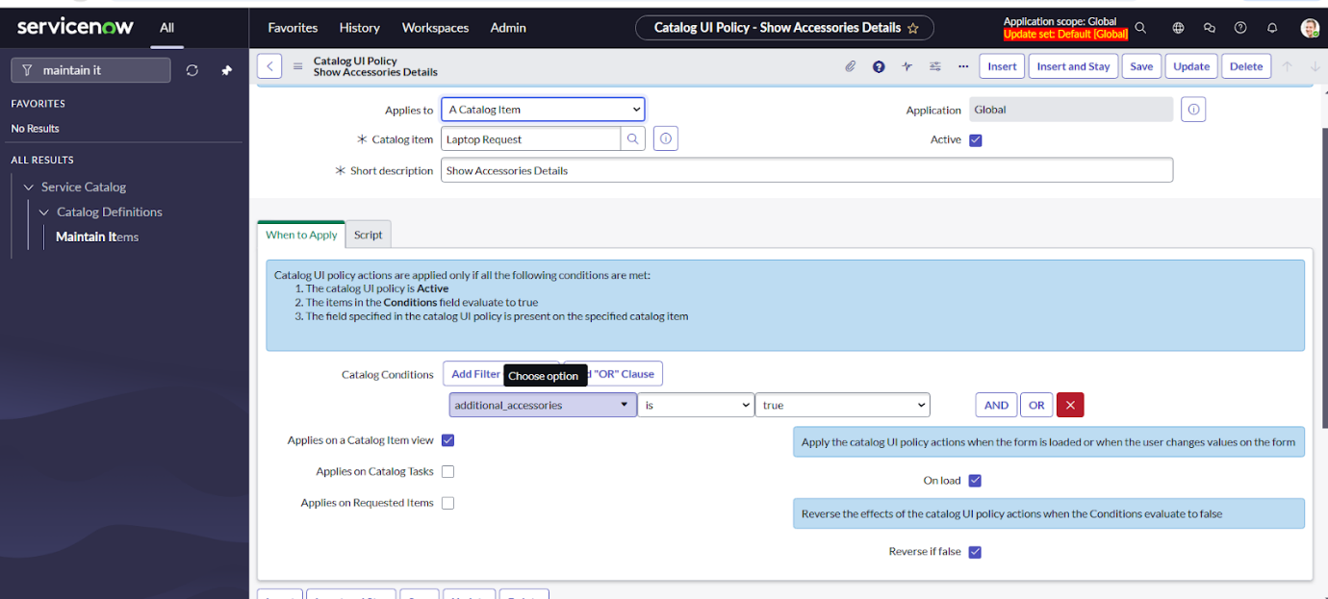

1. Click on **save**.(do not click on submit)
2. Scroll down and select ‘catalog ui action’
3. Then click on new button
4. Select variable name as: accessories_details

                              Order:100

                    Mandatory: True

                         Visible : True

1. Click on save and again click save button of the catalog ui policy form

